aNALYZE WEBSite CLICKSTREAM dATA To Detect malicious activities on the web site

Introduction
Clickstream data is an information trail a user leaves behind while visiting a website. It is typically captured in semi-structured website log files. Which contains Geographical data, Browsing Cookies Data and Time Line Data.
We can analyze this Data feeds to classify the website visitors According to their Loyalty to specific Site or specific Product, then we can recommend for those Users some Products with discount Capons, By Predicting which products do visitors tend to buy together.
First, we will Search for any malicious activity on this data feeds as a cleaning step, then classify the visitors into three main categories (Loyal, Guest, Normal) and according to their activity on the web site we can predict which products they tend to buy together.

Literature Review
The following two literature reviews attempt to demonstrate different ways to analyzing the Clickstream Data Logs.

Qiang Cao, Xiaowei Yang, Jieqi Yu, Christopher Palow.
Uncovering Large Groups of Active Malicious Accounts in Online Social Networks. Duke University and Facebook Inc.

In this Paper by Qiang Cao, Xiaowei Yang, Jieqi Yu, Christopher Palow. It views the design and implement a malicious account detection system called SynchroTrap. This system mainly clusters user accounts according to the similarity of their actions and uncovers large groups of malicious accounts that act similarly at around the same time for a sustained period of time.

Leyi Song, Xueqing Gong, Xiaofeng He, Rong Zhang, Aoying Zhou.
Multi-Stage Malicious Click Detection on Large Scale Web Advertising Data.
Center for Cloud Computing and Big Data, East China Normal University, 3663 North Zhongshan Road, Shanghai, China.

In the research article by Leyi Song, Xueqing Gong, Xiaofeng He, Rong Zhang, Aoying Zhou. Three main stages were described to filter malicious clicks.

First Stag was, Rule-based filtering, the Basic Idea is setting some parameters to build a rule to define threshold to filter malicious clicks on its value. For example, setting the maximum number for normal user behavior as the lower value of the two: number of clicks in one interval and number of periods the user clicks. Also he suggested for better accuracy, we can also determine the threshold based on the p-quantile value on the entire log dataset.

Second Filtering stage was, Classification-based filtering, mainly the user classify the Clickstream into two main classes (Traffic click, Normal User Click).

Third filtering stage was, Clustering-based filtering, clustering the clicks according to dissimilarity between selected set of features in the dataset.

Dataset
The Dataset is a web logs data for a fictitious web retail store Combined with traditional customer data and traditional products categories. You can find the Dataset at this URLhttps://s3.amazonaws.com/hw-sandbox/tutorial8/RefineDemoData.zip

This Dataset Contains
- 427811 total log records; 41 features.
- 30 Products with 14 different categories.
- 38545 unique Users (website Visitors) Anonymous Data.

In this Analysis we will Use some of the existing Dataset features and also do some feature engineering to have some useful features for our classification.

Approach

Step 1: Features Engineering & Exploratory Data Analysis (EDA).
In this step we will do some EDA Analysis like:
- Basic exploration:
  - Are there any outliers in the data set?
  - What is the distribution of the Visits Count in the Dataset?
- Center of the data set : Mean, median, and mode
- Spread of the data set : Range, variance, and standard deviation
- Shape of the distribution of the data set: Symmetry, skewness.
- Visual plot of data points:
  - Plot (scatterplot – Histograms - Boxplot) for the number of visits.
  - Correlation Plot between different features.
  - Removal of duplicate or highly correlated features.
  - Plot Geographical Data on MAP.

Step 2: Malicious Click Filtering.
- Features Extraction
  - using PCA
  - Building Malicious Rule to define the Threshold Value.
- Analysis Of Variance
  - Hypothesis testing and Run ANOVA Test

Step 3: Visitors Classification.
- Analysis Of Variance
- Find normal distribution for the visit count per user.
- Label the users into three main classes (Guest , Normal , Loyal )
- Run ANOVA Test on the three Groups.
- Divide the dataset into Training and Testing Data Sets.
- Run K-Mean Classification and SVM Classification.
- Compare the Two Classification Models.

Step 4: Visitors Product Recommendation.
- Demographical Analysis
  - Predict Products for users on age and gender and location.
  - Use linear regression to Predict / Recommend Product for users depending on their IP.

Github Link: https://github.com/shaimaasultan/ClickStream

Results
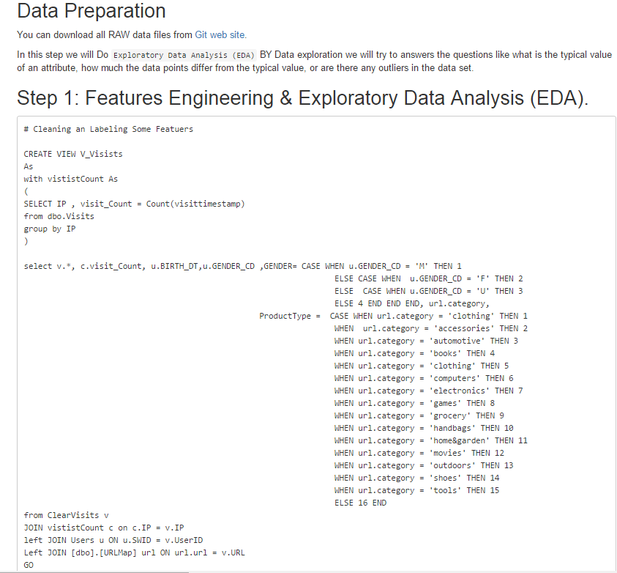
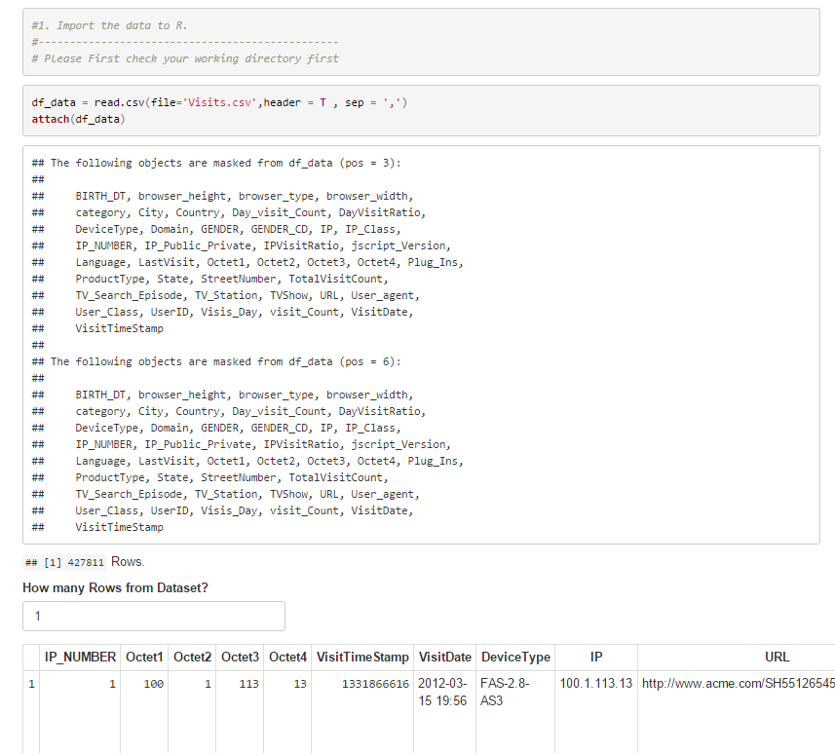
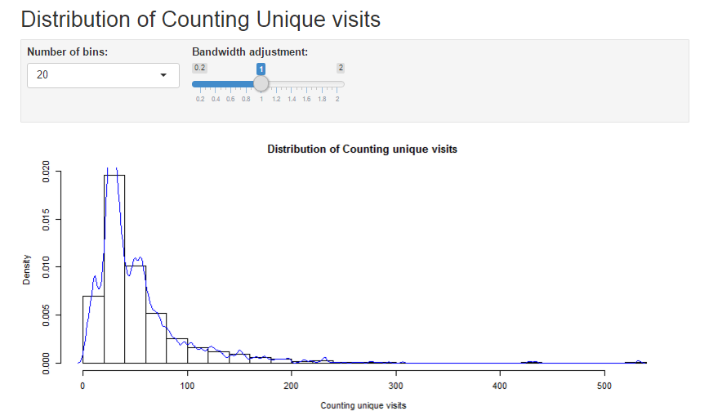
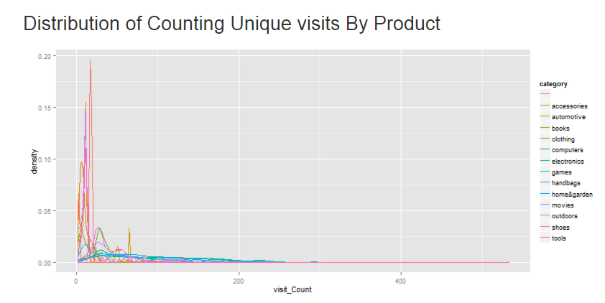
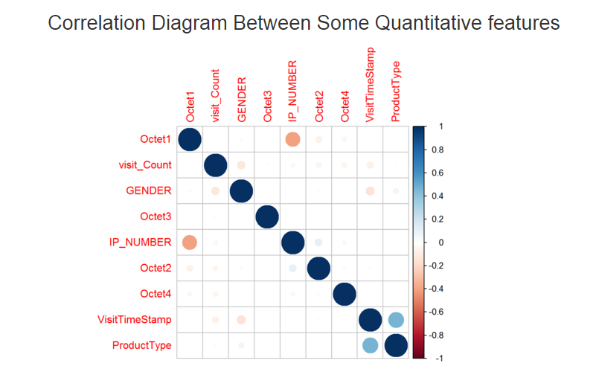
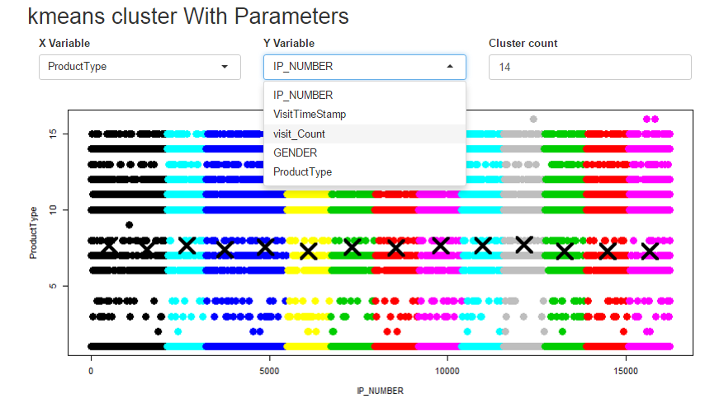

Step 2: Malicious Click Filtering & IP Analysis
First do some feature engineering on the Data to convert some Features into numeric Form.
- MAP IP Into numbers
- Classify IPs Into Public And Private
- Get IP Visits Ratio
- Get Day Visits Ratio
- Label IPs into 4 Classes According to Count of unique Visits
- Perform the Principal Component Analysis (PCA)
- Create An ANOVA Table
- Conduct a Tukey's Multiple Comparison Procedure
ALTER VIEW [dbo].[V_Visists]
As
with vististCount As
(
SELECT IP , visit_Count = Count(visittimestamp)
from dbo.Visits
group by IP
), VisitDayCount AS
(
SELECT VisitDay = DAY(visitDate) , Day_visit_Count = Count(visittimestamp)
from dbo.Visits
group by DAY(visitDate)
)
select IP_NUMBER = DENSE_RANK() OVER( order by v.IP), Octet1 ,Octet2,Octet3,Octet4 , v.*, c.visit_Count, u.BIRTH_DT,u.GENDER_CD ,
GENDER= CASE WHEN u.GENDER_CD = 'M' THEN 1
WHEN u.GENDER_CD = 'F' THEN 2
WHEN u.GENDER_CD = 'U' THEN 3
ELSE 4 END , url.category,
IP_Class = CASE WHEN c.visit_Count between 1 and 100 then 'A'
WHEN c.visit_Count between 101 and 200 then 'B'
WHEN c.visit_Count between 201 and 300 then 'C'
WHEN c.visit_Count between 301 and 400 then 'D'
WHEN c.visit_Count between 401 and 550 then 'E'
ELSE 'F' END,
IP_Public_Private = CASE WHEN Octet1 = 10
AND Octet2 between 0 and 255
AND Octet3 between 0 and 255
AND Octet4 between 0 and 255 then 'Private'
WHEN Octet1 = 172
AND Octet2 between 16 and 31
AND Octet3 between 0 and 255
AND Octet4 between 0 and 255 then 'Private'
WHEN Octet1 = 192
AND Octet2 = 168
AND Octet3 between 0 and 255
AND Octet4 between 0 and 255 then 'Private'
ELSE 'Public' END,
ProductType = CASE WHEN url.category = 'clothing' THEN 1
WHEN url.category = 'accessories' THEN 2
WHEN url.category = 'automotive' THEN 3
WHEN url.category = 'books' THEN 4
WHEN url.category = 'clothing' THEN 5
WHEN url.category = 'computers' THEN 6
WHEN url.category = 'electronics' THEN 7
WHEN url.category = 'games' THEN 8
WHEN url.category = 'grocery' THEN 9
WHEN url.category = 'handbags' THEN 10
WHEN url.category = 'home&garden' THEN 11
WHEN url.category = 'movies' THEN 12
WHEN url.category = 'outdoors' THEN 13
WHEN url.category = 'shoes' THEN 14
WHEN url.category = 'tools' THEN 15
ELSE 16 END,
Visis_Day = Day(VisitDate), dc.Day_visit_Count
from ClearVisits v
CROSS APPLY dbo.fn_ParseText2Table(v.IP,'.') AS octet
JOIN vististCount c on c.IP = v.IP
JOIN VisitDayCount dc ON dc.VisitDay = Day(VisitDate)
left JOIN Users u ON u.SWID = v.UserID
Left JOIN [dbo].[URLMap] url ON url.url = v.URL
GO

Unique Visits Count Group By IPs
df_data = read.csv(file='Visits.csv',header = T , sep = ',')
attach(df_data)
boxplot(visit_Count~IP_Class, col=c('Green','RED','BLUE','GRAY','YELLOW'))
legend('topleft','GROUP',c('A (1-100)','B (101-200)','C (201-300)','D (301-400)','E (401-550)') , col=c('Green','RED','BLUE','GRAY','YELLOW'), lty = 1)
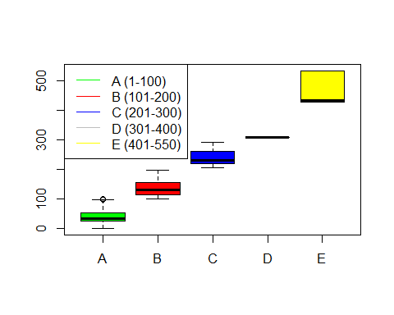

Create An ANOVA Table
dat_aov <- aov(visit_Count~IP_Class)
summary(dat_aov)
## Df Sum Sq Mean Sq F value Pr(>F)
## IP_Class 4 820644294 205161074 412252 <2e-16 ***
## Residuals 427806 212901748 498
## ---
## Signif. codes: 0 '***' 0.001 '**' 0.01 '*' 0.05 '.' 0.1 ' ' 1
# Conduct a Tukey's Multiple Comparison Procedure
TukeyHSD(dat_aov)
## Tukey multiple comparisons of means
## 95% family-wise confidence level
##
## Fit: aov(formula = visit_Count ~ IP_Class)
##
## $IP_Class
## diff lwr upr p adj
## B-A 97.06549 96.74637 97.38461 0
## C-A 200.72352 199.92835 201.51869 0
## D-A 267.31330 263.83889 270.78771 0
## E-A 430.29824 428.66601 431.93048 0
## C-B 103.65803 102.81266 104.50340 0
## D-B 170.24781 166.76157 173.73404 0
## E-B 333.23275 331.57548 334.89002 0
## D-C 66.58978 63.02827 70.15128 0
## E-C 229.57472 227.76447 231.38498 0
## E-D 162.98495 159.14877 166.82112 0

Perform the Principal Component Analysis (PCA)
df_PCA <- cbind(IP,IP_Class,IP_NUMBER,visit_Count,Octet1,Octet2,Octet3,Octet4,GENDER,ProductType,Day_visit_Count,DayVisitRatio,Visis_Day,VisitTimeStamp,URL,TVShow,TV_Station,Domain)
#pairs(df_PCA)
result_PCA <- princomp(df_PCA,scores = TRUE,cor = TRUE)
summary(result_PCA)
## Importance of components:
## Comp.1 Comp.2 Comp.3 Comp.4 Comp.5
## Standard deviation 1.5786895 1.5145426 1.4294162 1.3620662 1.08178393
## Proportion of Variance 0.1384589 0.1274355 0.1135128 0.1030680 0.06501425
## Cumulative Proportion 0.1384589 0.2658944 0.3794072 0.4824753 0.54748950
## Comp.6 Comp.7 Comp.8 Comp.9
## Standard deviation 1.02258492 1.02129875 1.00491733 0.99526843
## Proportion of Variance 0.05809333 0.05794729 0.05610327 0.05503107
## Cumulative Proportion 0.60558283 0.66353012 0.71963339 0.77466445
## Comp.10 Comp.11 Comp.12 Comp.13
## Standard deviation 0.97417313 0.96532705 0.86892500 0.84823948
## Proportion of Variance 0.05272296 0.05176979 0.04194615 0.03997279
## Cumulative Proportion 0.82738741 0.87915721 0.92110336 0.96107615
## Comp.14 Comp.15 Comp.16 Comp.17
## Standard deviation 0.77177029 0.321654901 3.921862e-02 9.946734e-07
## Proportion of Variance 0.03309052 0.005747882 8.544999e-05 5.496529e-14
## Cumulative Proportion 0.99416667 0.999914550 1.000000e+00 1.000000e+00
## Comp.18
## Standard deviation 0
## Proportion of Variance 0
## Cumulative Proportion 1
#Print the Scree Plot
plot(result_PCA)
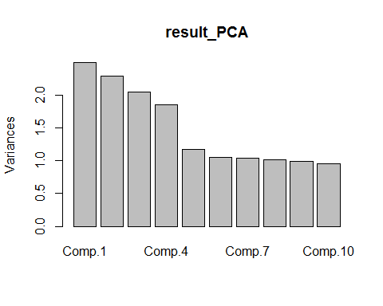

Create train data & test data
comp_df_data <- df_data[complete.cases(df_data),]
df_train <- comp_df_data[sample(1:nrow(comp_df_data),nrow(comp_df_data) * .7),]
df_test <-comp_df_data[sample(1:nrow(comp_df_data),nrow(comp_df_data) * .3),]
train_Classes <- df_train['User_Class']
dt_test_class <- df_test['User_Class']

Classify Users To Four Diffrent Categories (Loyal , Active , Normal , Geust )
#----------------------------------------------------------
#Module 2) - Apply knn from Class package
#==========================================================
#load calss
library(class)
#Apply knn

Users Classes Click frequency Analysis
plot(User_Class,visit_Count,type="p", lwd=1.5,lty=2, col= c('red'), pch=4 )
